**Create bookmarks in Power BI Desktop to share insights and build stories**

Bookmarks: An excellent option in power BI to create stories out of your data. This can be asked in various ways:

1. What are bookmarks?
2. How can you toggle between reports? This can be done by using bookmarks as well as by using other ways too. It can be done with the help of buttons, through actions, drill through, drill down.

With bookmarks in Power BI Desktop, you capture the currently configured view of a report page, including filtering and the state of visuals. Later, you can go back to that state by selecting the saved bookmark. You can also create a collection of bookmarks, arrange them in the order you want, and later step through each bookmark in a presentation to highlight a series of insights, or the story you want to tell with your visuals and reports.

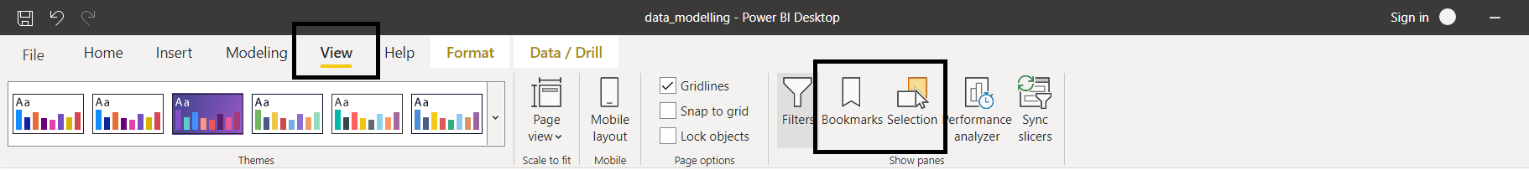

Creating Bookmark 1: Overall Sales

Create the bookmark and update it.

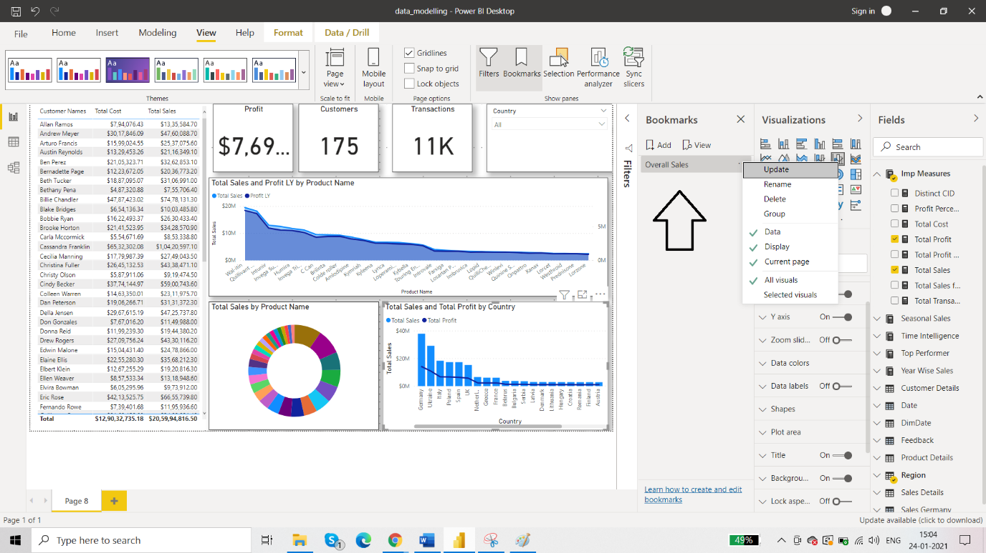

Creating Bookmark 2: Sales Denmark

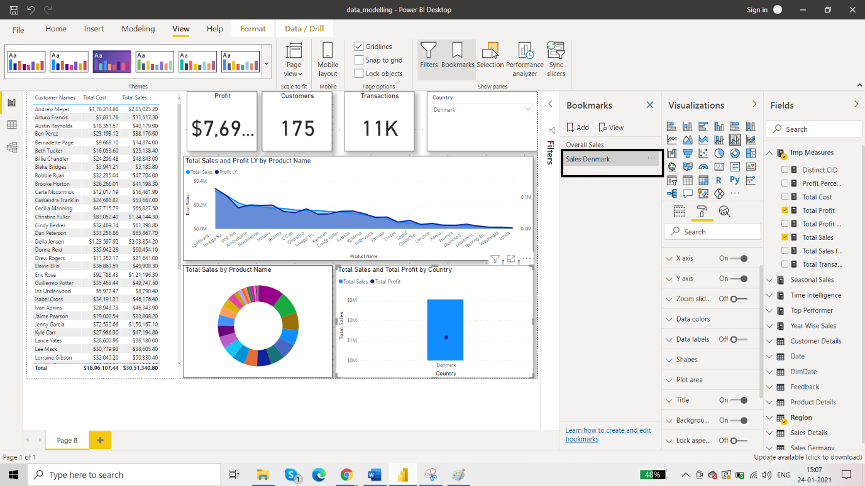

Creating Bookmark 3: Finland

But here we want to highlight just the area chart and not any other visual for Finland. So, select the country Finland from the slicer and go to the visual that you wish to highlight, here it is area chart. So, go to the upper right corner on area chart called “focus mode” then add the bookmark.

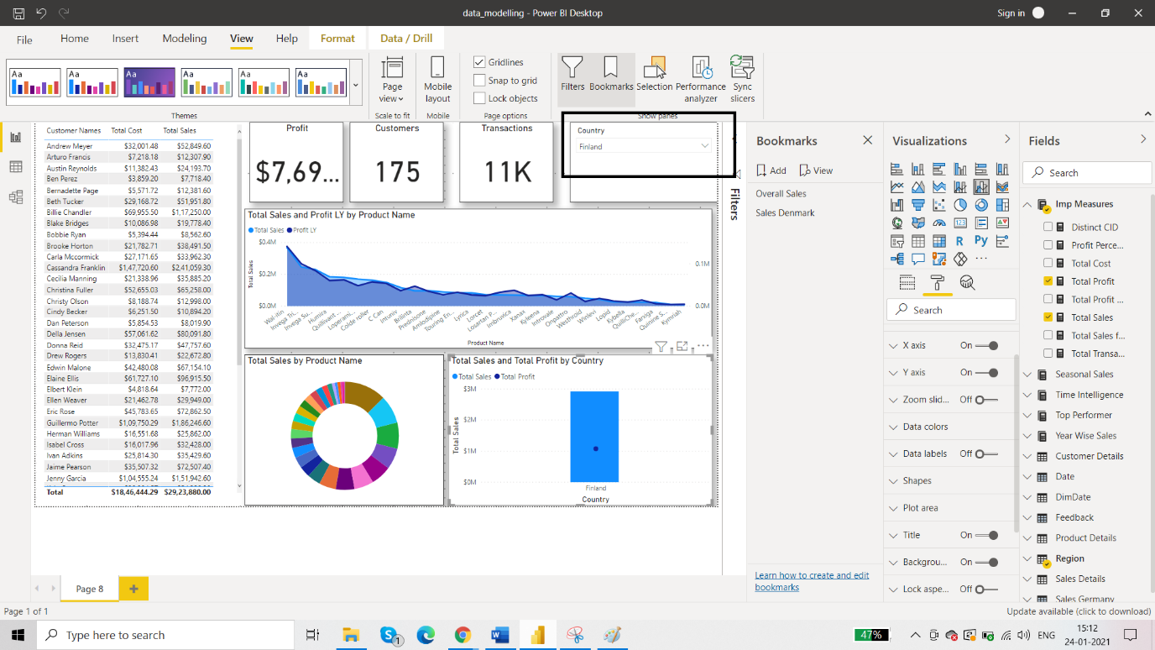

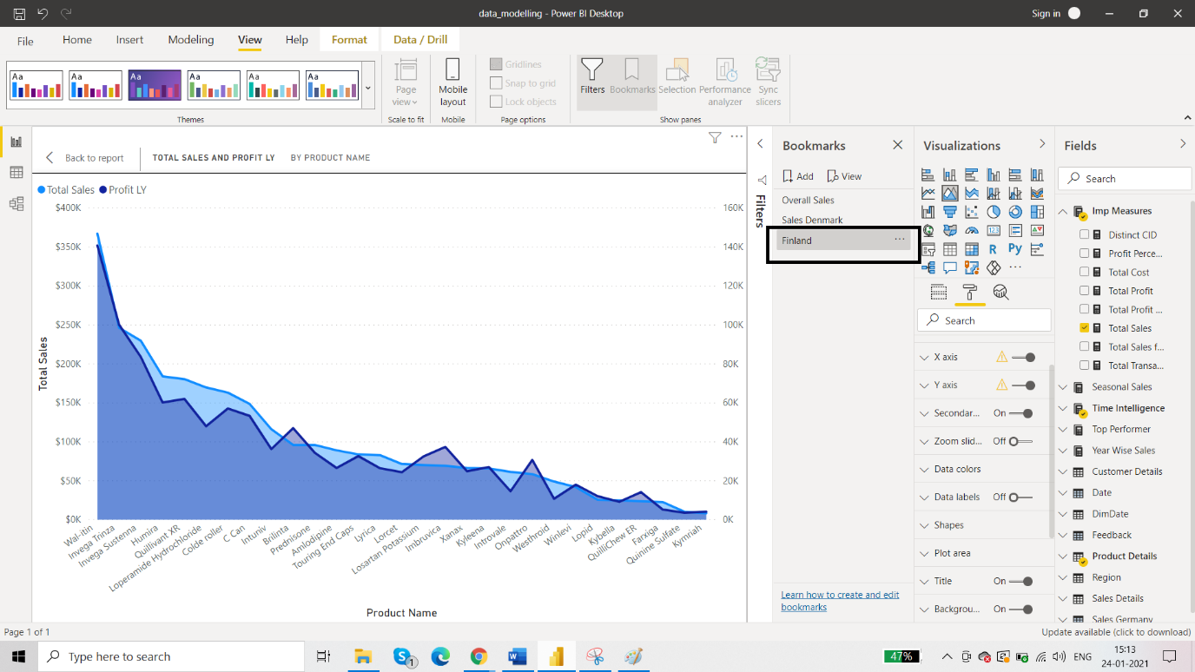

Creating Bookmark 4: Germany

For Germany we don’t want to sakes vs profit visual. So firstly select Germany from the slicer. Then:

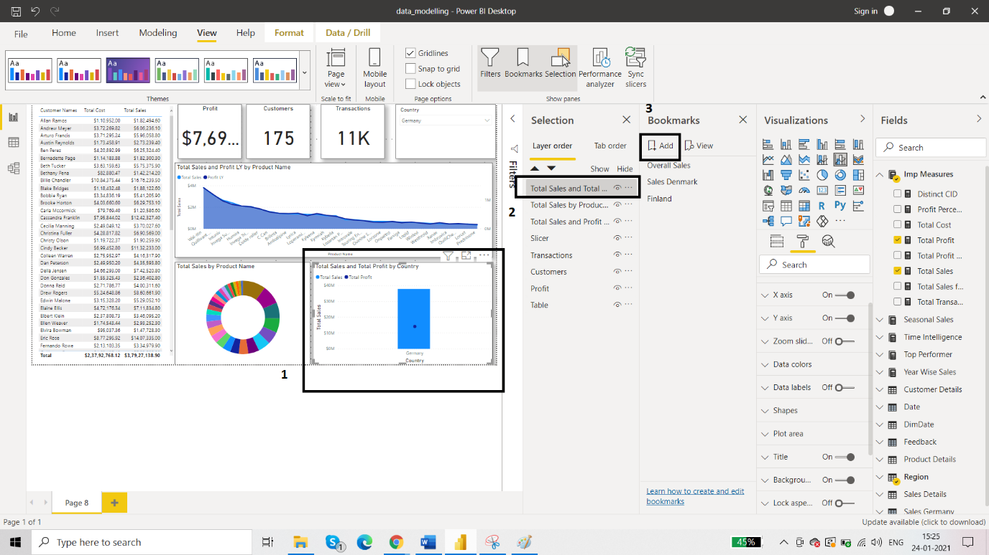

You will get:

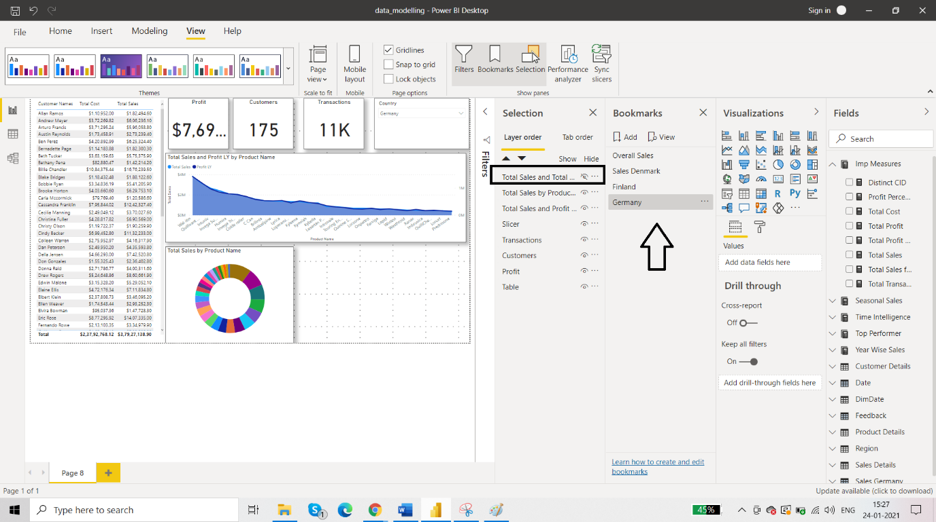

Now you can click on the eye icon again to bring back that visual.

All the bookmarks are done, so we will check the bookmarks. Click on ‘view’ from the bookmark panes.

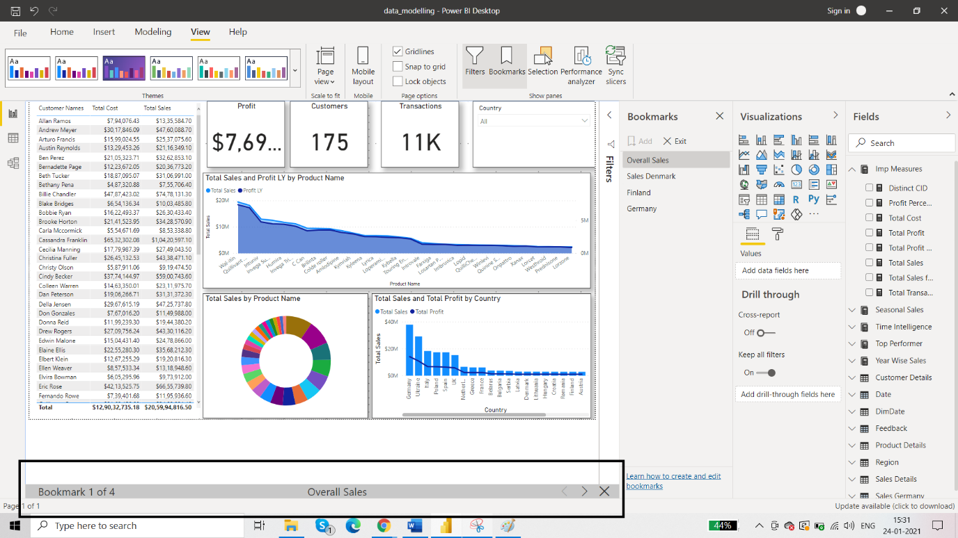

# Use buttons in Power BI : same page

Using **buttons** in Power BI lets you create reports that behave similar to apps, and thereby, create an engaging environment so users can hover, click, and further interact with Power BI content. You can add buttons to reports in **Power BI Desktop** and in the **Power BI service**. When you share your reports in the Power BI service, they provide an app-like experience for your users.

You can navigate through pages with the help of buttons is another interesting feature of bookmarks.

Create an image in powerpoint and save it as jpeg format.

In powerbi create these two visuals:

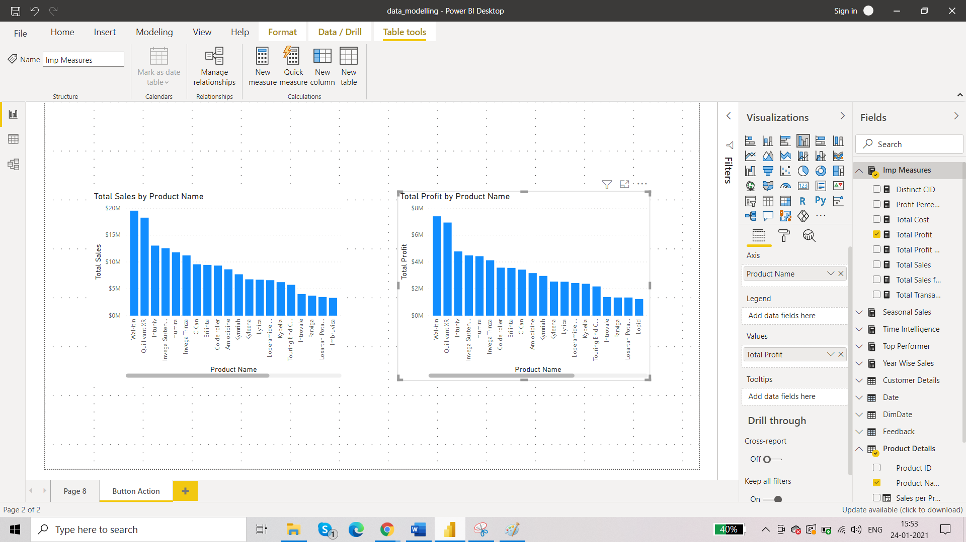

Then add the image as the page background.

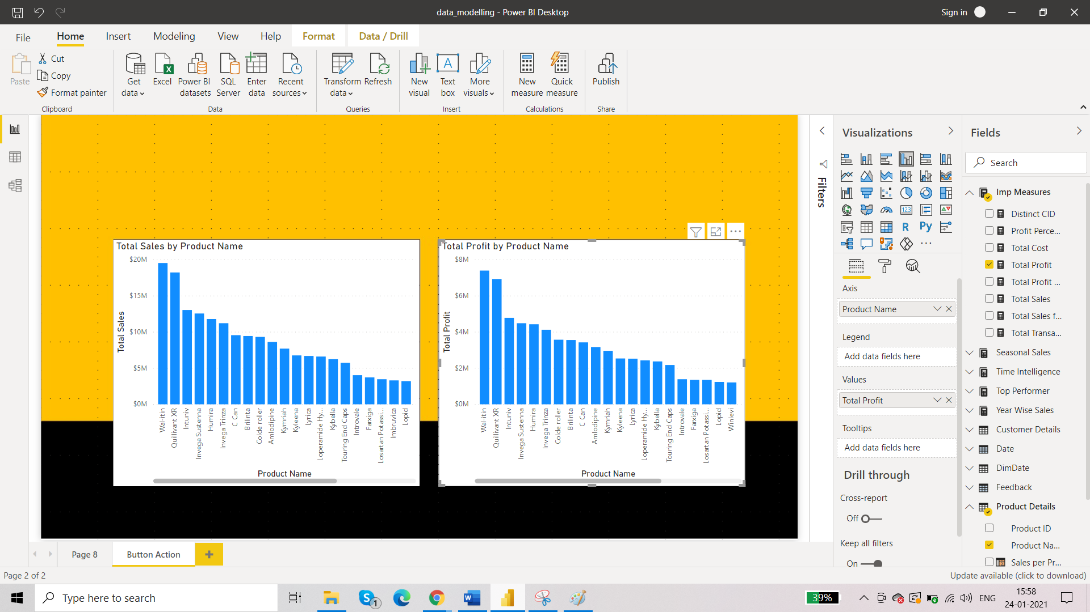

From insert menu add 3 buttons: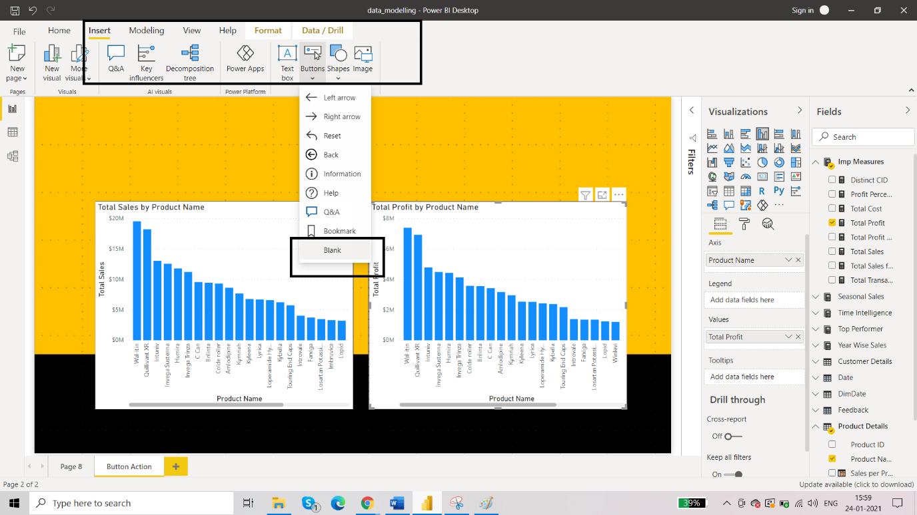

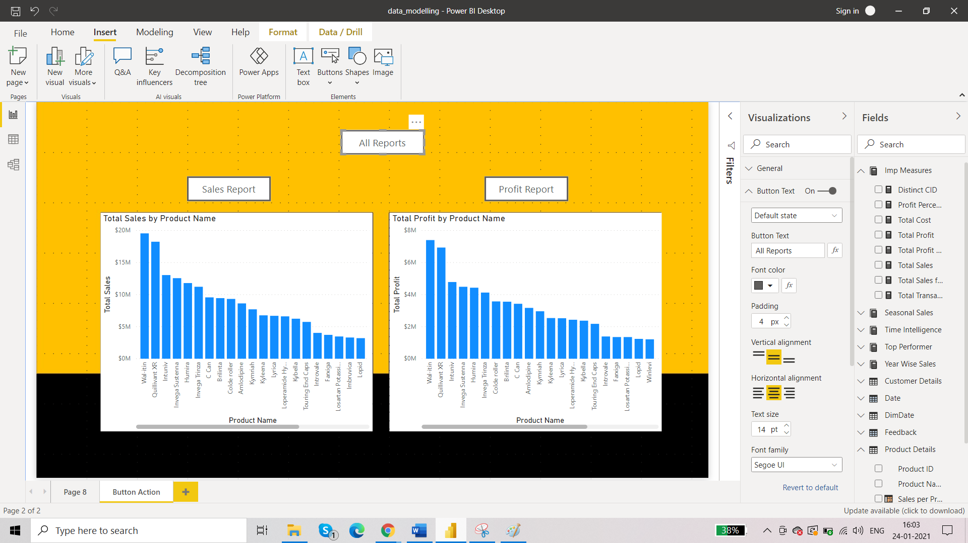

On clicking

* All Reports: Both visuals will appear
* Sales Reports: Sales vs product visual appears
* Profit Report: Profit vs product visual appears

For buttons 3 things are to kept in mind:

* Create the buttons
* Create role for the buttons (here, bookmarks)
* Assign those roles to the buttons

Here are the options for button actions:

* **Back** returns the user to the previous page of the report. This is useful for drill-through pages.
* **Bookmark** presents the report page that's associated with a bookmark that is defined for the current report. Learn more about [bookmarks in Power BI](https://docs.microsoft.com/en-us/power-bi/create-reports/desktop-bookmarks).
* **Drill through** navigates the user to a drill-through page filtered to their selection, without using bookmarks. Learn more about [drill-through buttons in reports](https://docs.microsoft.com/en-us/power-bi/create-reports/desktop-drill-through-buttons).
* **Page navigation** navigates the user to a different page within the report, also without using bookmarks. See [Create page navigation](https://docs.microsoft.com/en-us/power-bi/create-reports/desktop-buttons#create-page-navigation) in this article for details.
* **Q&A** opens a **Q&A Explorer** window.

Now, create three bookmarks as per these three buttons.

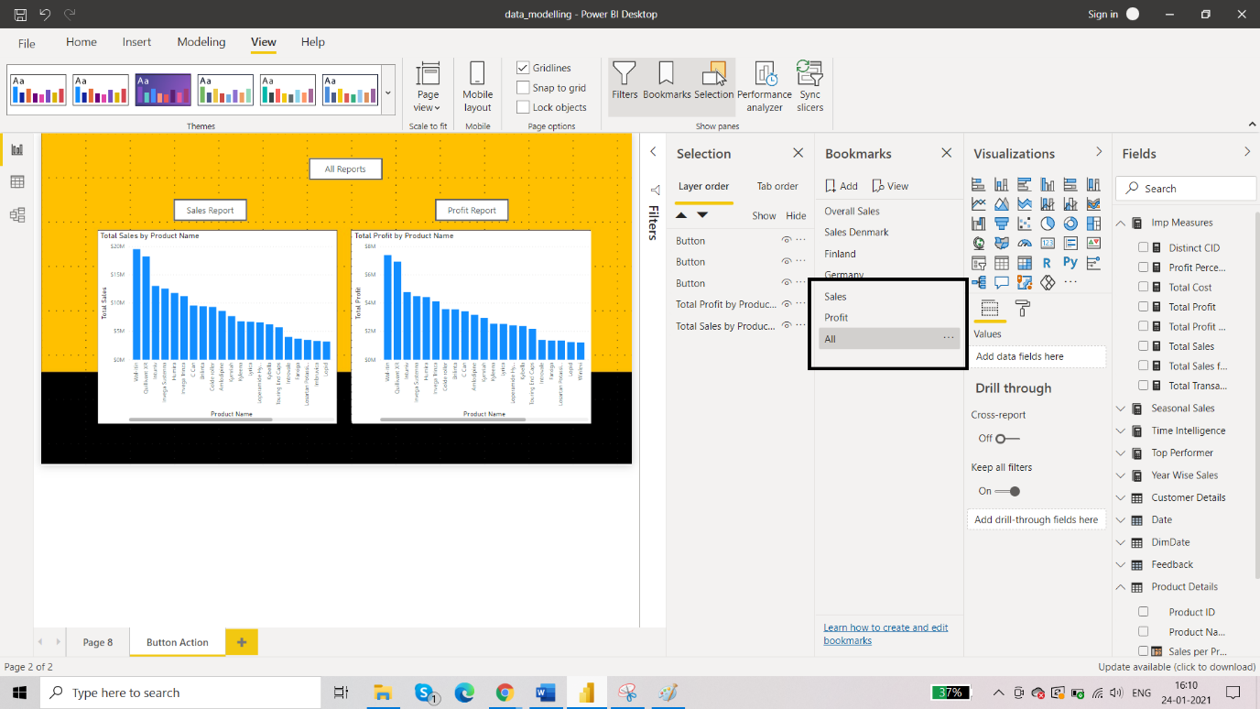

Last step to assign the action.

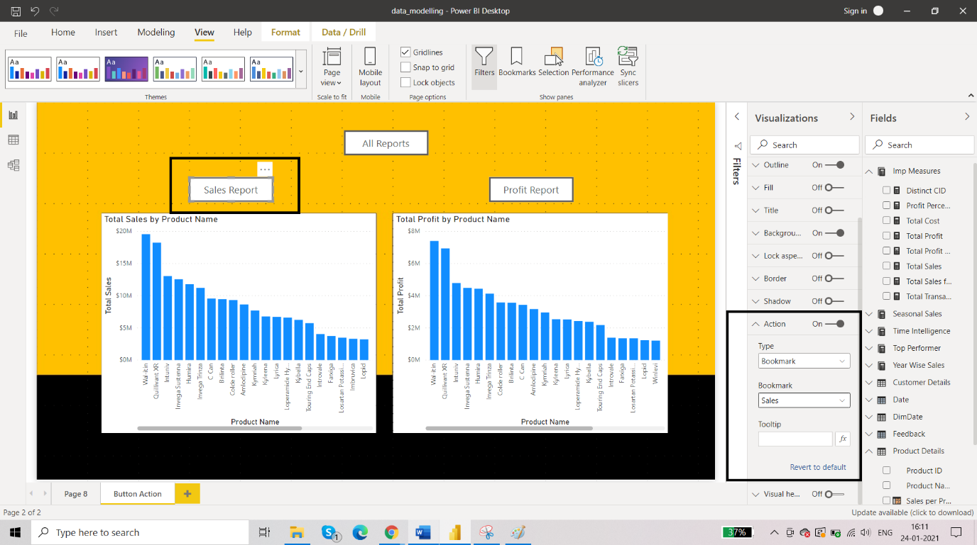

Test the buttons by clicking on them while holding ctrl key.

# Use buttons in Power BI : different pages

# Create one more button called Profit YTD

# For the action:

# 

Test the button by clicking on it while holding ctrl key.

# Use filters in Power BI : visuals

# We have seen filters at the power query level and at the data modelling stage and with the DAX too. Now we are going to see the filters at the visual level. So there are three kinds:

# Visual level filter

# Page level filter

# Report level filter

# All three types of these filters can be applied by using the filter pane.

# 

# Question: what is the difference between slicer and filter?

# If you want to apply filter on all pages then you have to apply separately but one slicer can be synced across all pages.

# 

## **Drillthrough**

Drillthrough filters get passed from one page to another via the drillthrough feature. They show up in the drillthrough pane. There are two types of drillthrough filters. The first type is the one that invokes the drillthrough. Report editors can edit, delete, clear, hide, or lock this type of filter. The second type is the drillthrough filter that gets passed to the target, based on the page-level filters of the source page. Report editors can edit, delete, or clear, this transient type of drillthrough filter. They can't lock or hide this filter for end users.

In simple words, drill through means accessing one visual with the help of another visual.

Requirement: donut chart displays sales as per the product but you want more details as per the product like country through this donut chart. This means when you click on a particular product on the donut chart then you will be taken to a different report where all the details as per country will be shown. So we are going to use this donut chart as a point of interaction to another report.

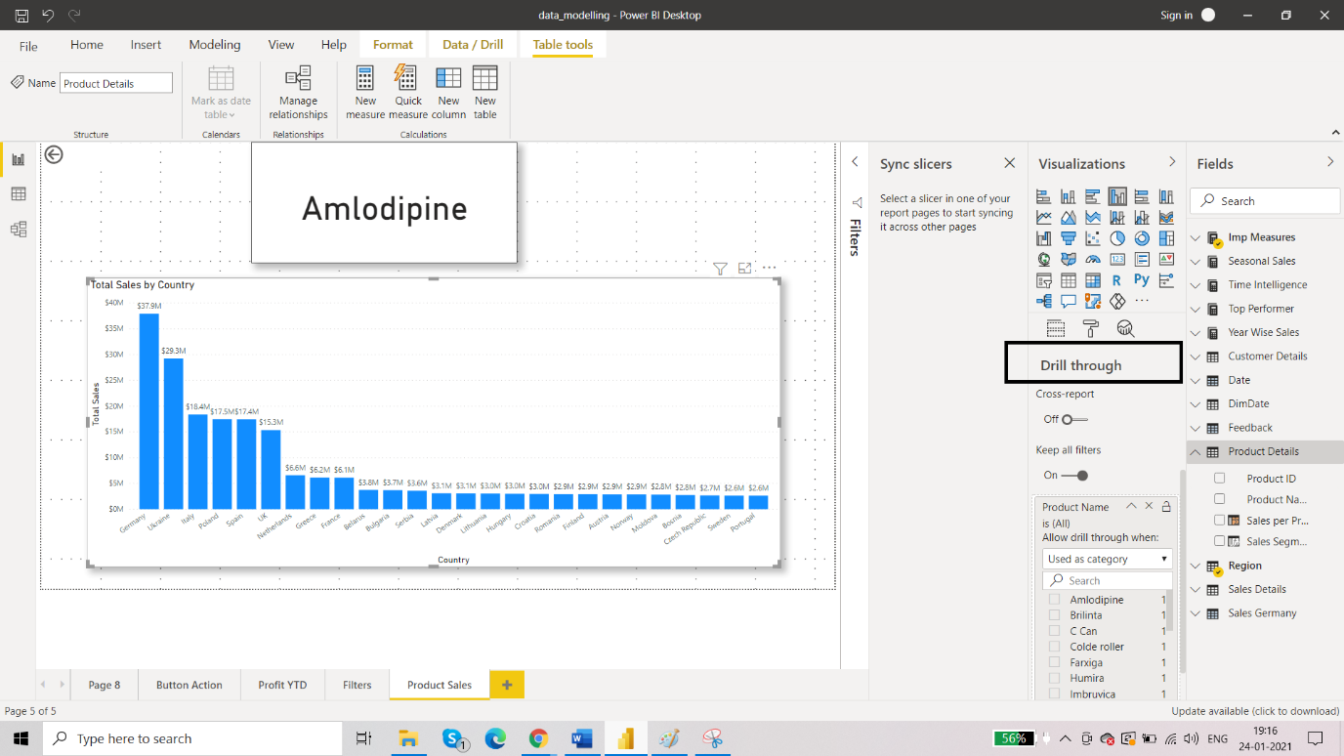

Now go back to dashboard:

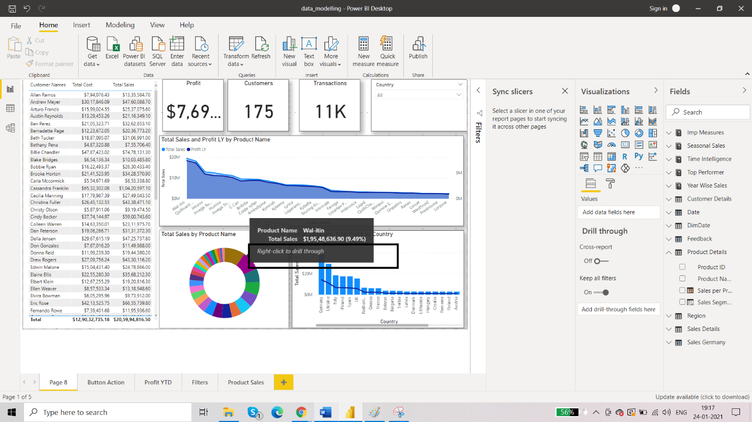

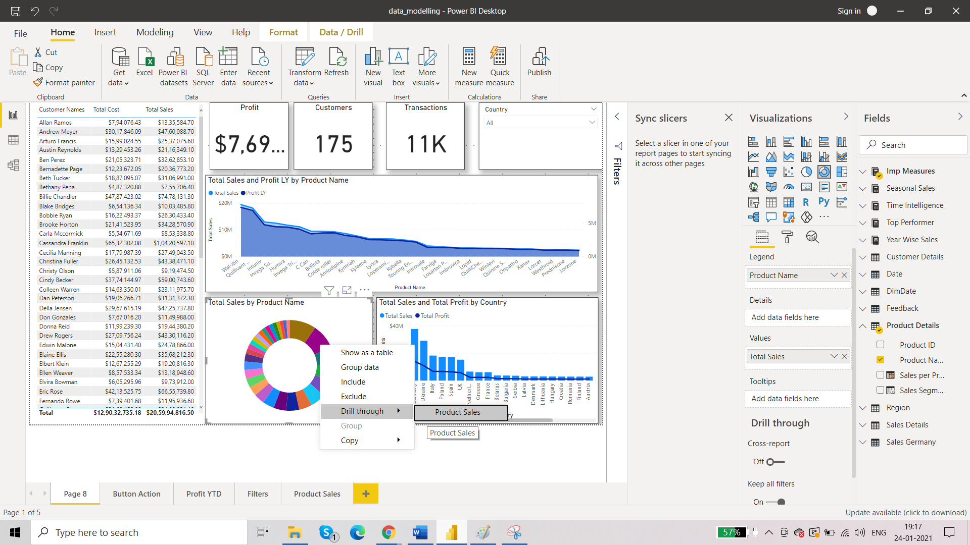

Click on Product Sales and you will be re directed to Product Sales page with all the details relevant to this product:

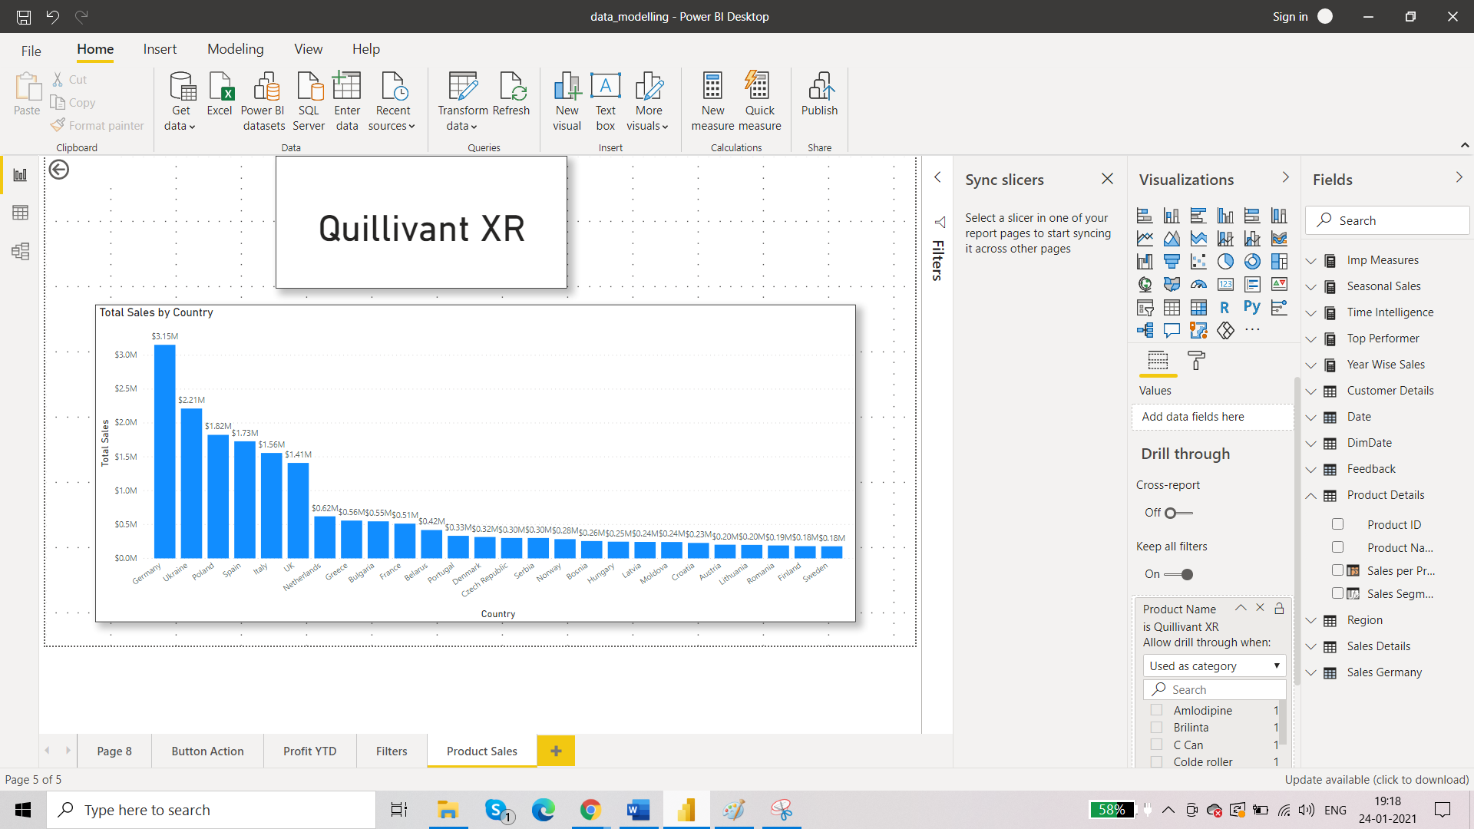

Click on the arrow with ctrl key and you will be taken back to your original report.

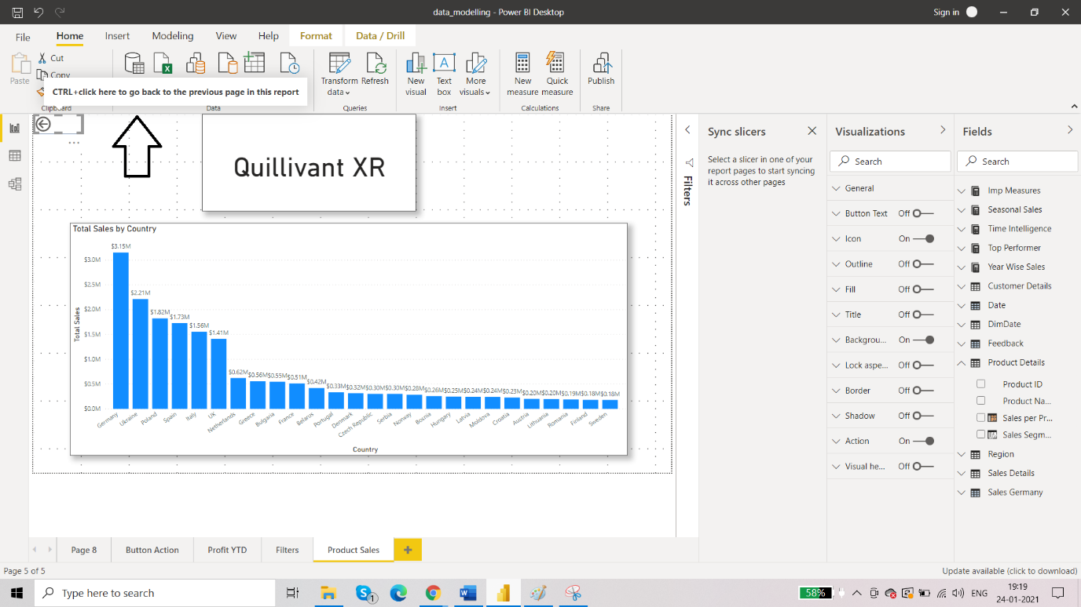

Toggling between reports:

* Bookmarks
* Drill through
* Drill down

## **Drilldown**

## The functionality of drill through can be achieved on the same report too with the help of drill down. In power bi there is one visual which has built in functionality of drill down available. This visual is known as matrix table.

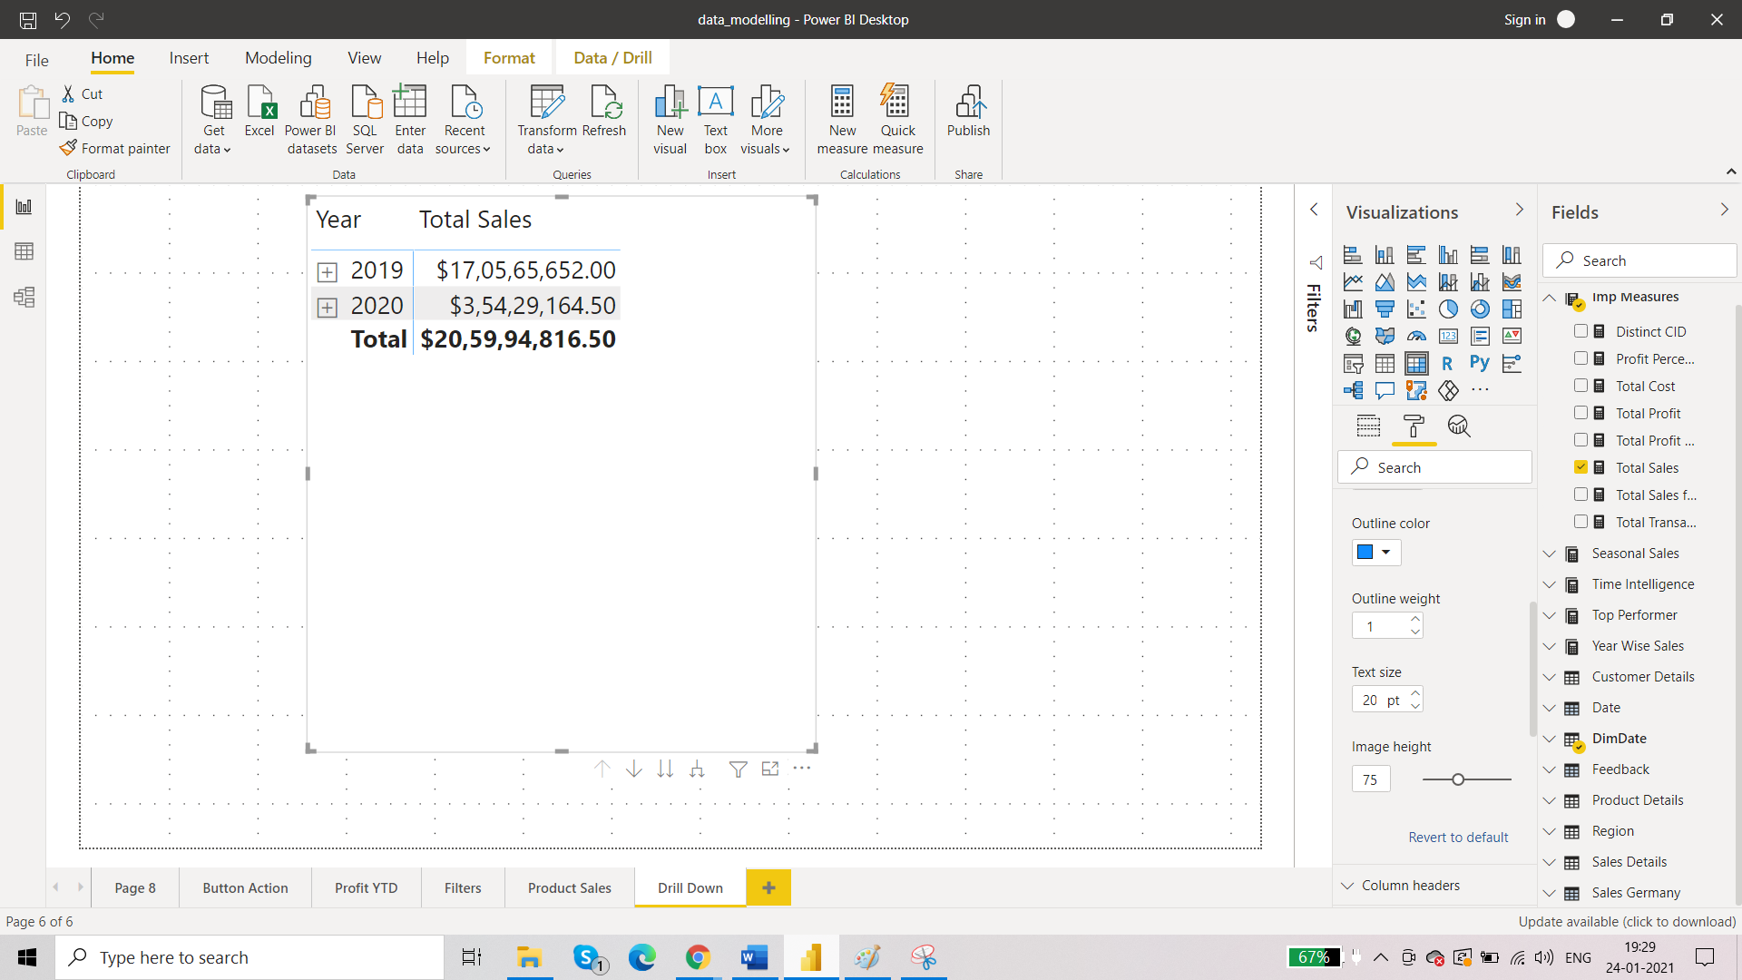

+ : drill down, - : drill up

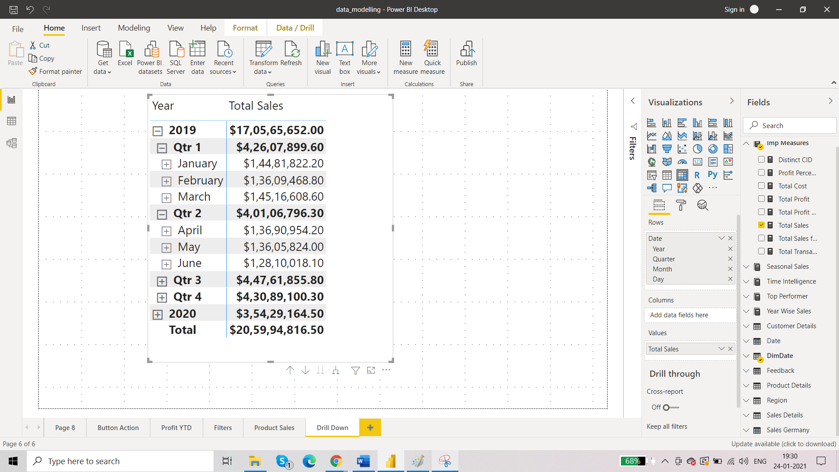

This is the default behaviour of the matrix table.

Now let us try to achieve drill down on column chart. Date is in hierarchical format and there you can see some arrows which enable the drill down functionality.

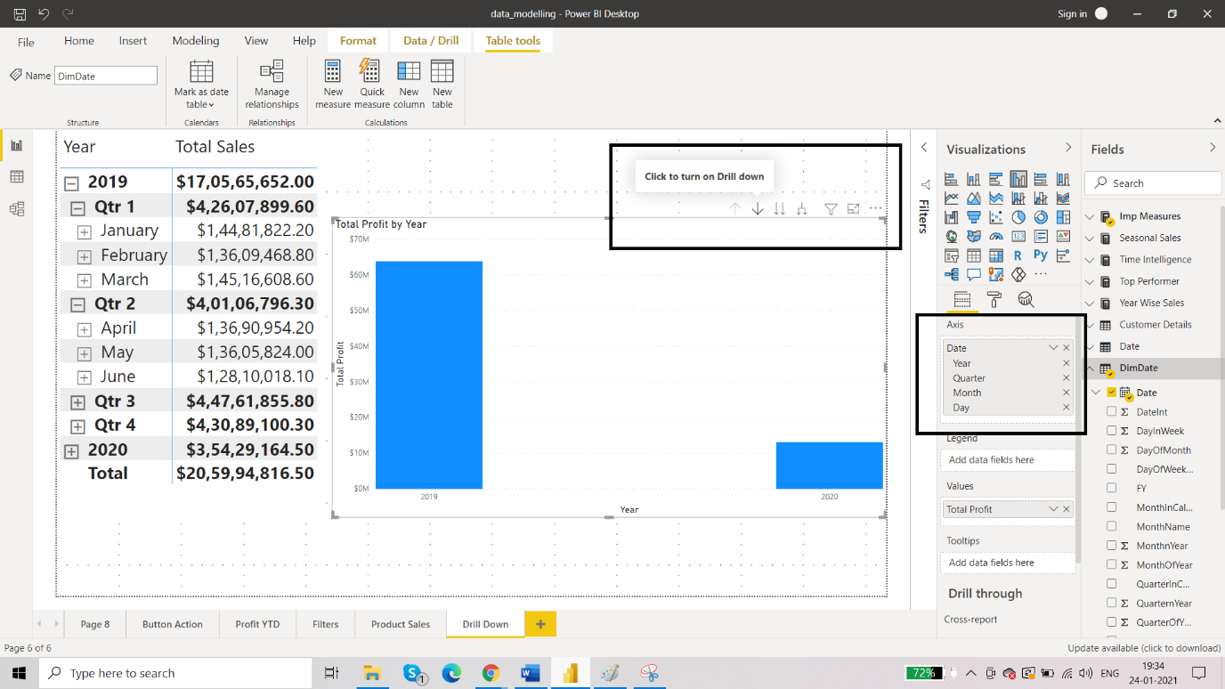

Make sure that the date in x axis is : categorical

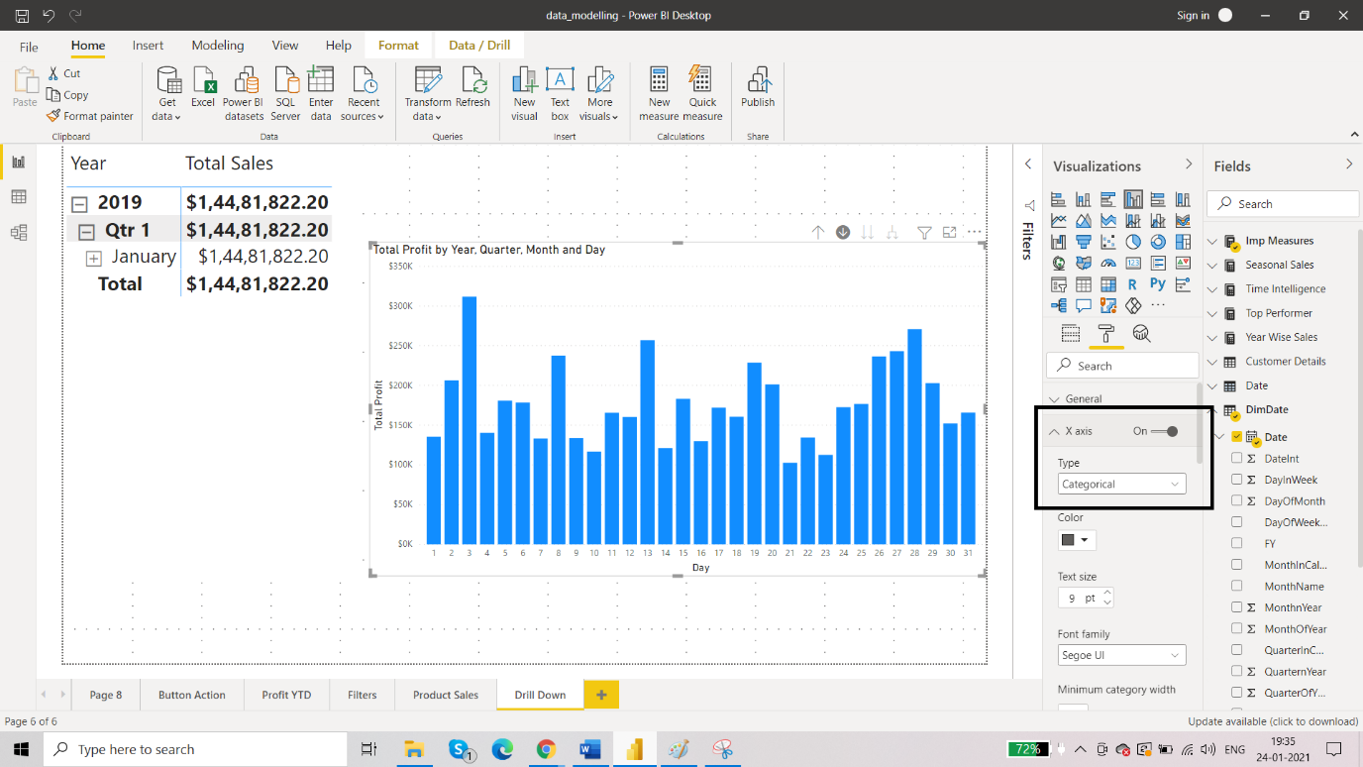

Now instead of date, we want to use another hierarchy.

